- ATTENTION -
2003 Graduating Class at

Jonesboro-Hodge High School

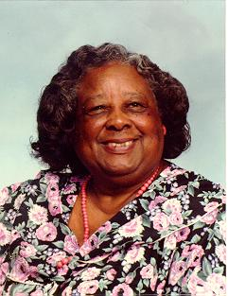Application forms for the

Thelma Wilson Jenkins Scholarship

Are available from

The Guidance Counselor
Jonesboro-Hodge High School
OR
http://ThelmaWilsonJenkinsScholarship.org

