The Thelma Wilson Jenkins Scholarship was organized in 2002 to serve, promote, and assist Jonesboro–Hodge High School Students who plan to attend college. The fundamental purpose of the scholarship is to provide financial assistance to a deserving student and to offer opportunities for improvement of skills and advancement of knowledge. Scholarship awards will be granted in May of each academic year.

The application process is open to High School Seniors who attend Jonesboro–Hodge High School and are residents of Jackson Parish, Louisiana. The scholarship must be used to defray college tuition at an accredited college or university. Awards on the recipient’s behalf are made payable directly to the college or university. Applicants may attend college on a full or part-time basis.

This is a merit-based scholarship, awarded on the basic of academic achievement, community involvement, social involvement, spiritual commitment, and personal recommendations.

A panel of volunteer judges will represent a cross-section of academic and community individuals. The decision of the judges is final. The finalist MUST appear for a personal interview when scheduled, dressed in appropriate business attire.

SUPPORTING MATERIALS

1. Attach an essay of 1½ to 3 double-spaced pages outlining your career goals and how your course of study will support those goals (type written). This essay is important, but not the key part of the application. The judges will look for a demonstrated ability to communicate clearly, carefully, and creatively.

2. Attach a copy of high school transcript or report card.

3. Submit up to (3) three short letters of recommendation articulating your qualifications for The Thelma Wilson Jenkins Scholarship; At least one (1) letter from your Minister, Youth Minister, or Youth Director and at least (1) one letter from a Jackson High Alumni indicating the writer’s affiliation with Jackson High School and his or her relationship to you. Recommendations from relatives are not acceptable.

4.) Please include a photo (maximum size 3 .5 by
5.5 inches)
Completed application and supportive materials must be submitted to the guidance counselor before the last school day in March.

Or mailed before the last
school day in March to:

Thelma Wilson Jenkins Scholarship Committee
Post Office Box 57302
Webster, Texas 77598

EMAIL: info@ThelmaWilsonJenkins.com
Website: http://ThelmaWilsonJenkinsScholarship.org

Mrs. Thelma Wilson Jenkins was a resident of Jackson Parish from the age of 5. She was a Christian, active as a community leader, educator and Church leader. She taught school in Jackson Parish for 30 years and served as Director for the Galilee Day Care for years. Throughout her lifetime, Mrs. Jenkins was constantly encouraging students to finish high school and to prepare themselves for gainful employment by continuing their education beyond high school.

The Thelma Wilson Jenkins Scholarship Fund was established to perpetuate the memory of Mrs. Thelma Wilson Jenkins. This fund will be awarded in her name to promising and deserving Jonesboro-Hodge High School graduates.

She was different, she was special, and unique in a thousand ways. She was giving, she was loving and we’ll miss her all our days. She knew sorrow in great measure, and was stung by illness, too. But neither could defeat her, nothing could her faith subdue.

"A teacher affects eternity; she can never tell where her influence stops."
Henry Adams

For wisdom is a defense and money is a defense: but the excellency of knowledge is, that wisdom giveth life to them that have it.
Ecclesiastes 7:12

Education

Makes people easy to lead, but difficult to drive;
easy to govern, but impossible to enslave.

The

Thelma Wilson Jenkins
Scholarship

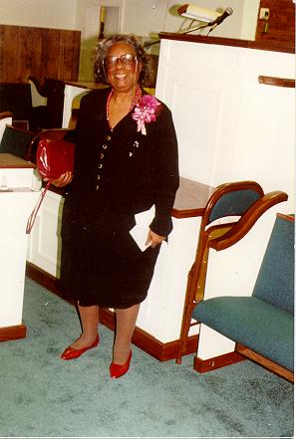

A $500.00 Scholarship

for College

Thelma Wilson Jenkins Scholarship Committee
Post Office Box 57302
Webster, Texas 77598

